These queries are used to fetch the most expensive products from the product table by sorting products in descending order of price.
The first query displays only selected columns (product_id, product_name, price) and returns the top 5 highest-priced products.
The second query displays all product details and returns the top 7 highest-priced products.

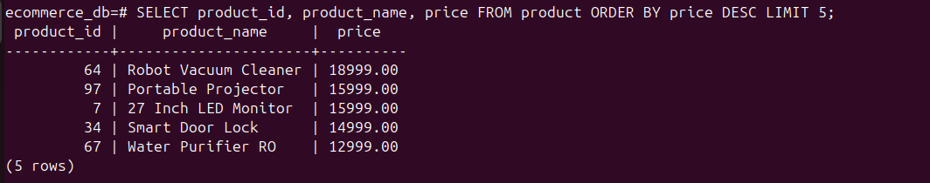

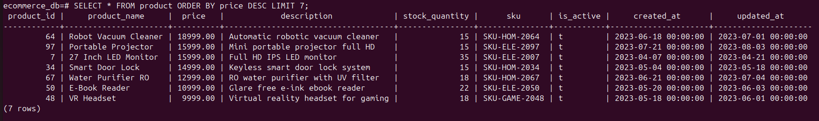

Benefit:
Helps identify high-value and premium products.
Useful for price analysis, reporting, and showcasing top-priced items.

